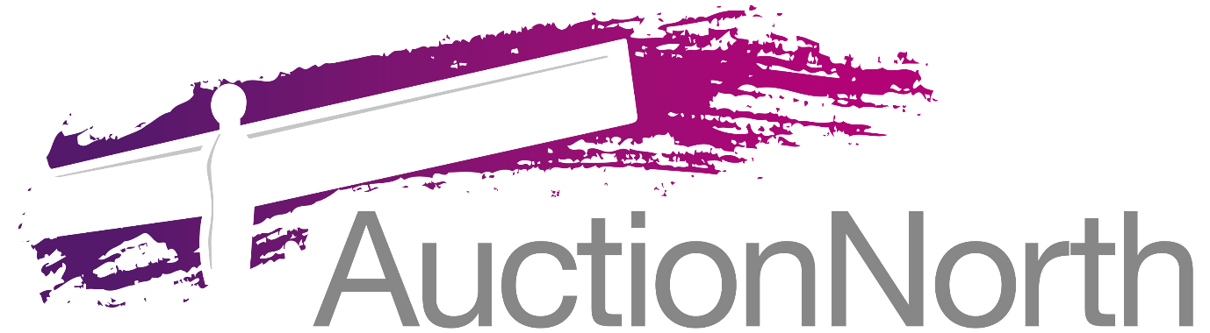

RESERVATION AGREEMENT – Modern Method of Auction
Agents: Auction North Limited (CRN: 10762287) whose registered office address is Suite 4, Kingfisher House St. Johns Road, Meadowfield Industrial Estate, Durham, England, DH7 8TZ.
Property: ………………………………………………………………………………………………………………………… (freehold/leasehold)
Vendor(s): Name(s)……………………………………………………………………………………………………………..................................
Correspondence Address…………………………………………………………………………………………………………………………………….
……………………………………………………………………………………………………………………………………………………………………………
Purchaser(s): Name(s)………………………………………………………………………………………………………………………………………...
Correspondence Address…………………………………………………………………………………………………………………………………….
……………………………………………………………………………………………………………………………………………………………………………
Telephone……………………………………………………………………………………………………………………………………………………………
Email ……………………………………………………………………………………………………………………………………................................
Purchase Price:…………………………………………….
Agreed Deposit:……………………………………………
Date of Auction: …………………………………….....
Estimated date of Exchange: 28 days after the Date of Auction
Estimated date of Completion: 56 days after the Date of Auction

The Purchaser(s) hereby agrees that they have put forward the winning bid on the above Property at auction and hereby agree to pay the above Reservation Fee to the Agents and agree to be bound by the conditions of reservation relevant to this Property and in accordance with the Terms and Conditions of the Agents relating to the modern method of auction. The Purchaser(s) hereby acknowledge(s) that the Reservation Fee will not be refundable in any circumstances save for the Vendor(s) withdrawing from the sale of the Property.
Purchaser(s) Signature…………………………………………………………………………………………………………………………………………
Print Name………………………………………………………………………………………………………………………………………………………….
Date…………………………………………………………………………………………………………………………………………………………………….

